IP Camera
Smartphone-ready colour night/day
network camera with pan, tilt and zoom

DYN-631
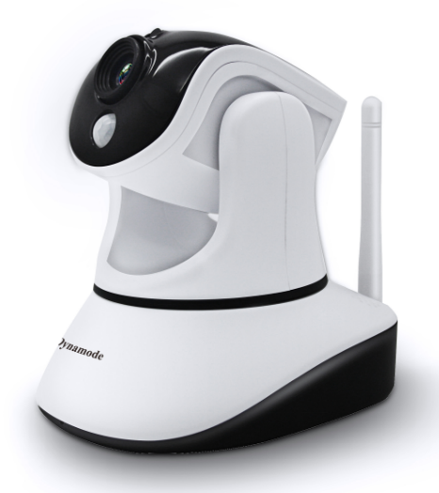

SPECIFICATIONS:
- Product type: IP camera
- Operation system: Embedded operating system
- Web protocol: TCP/IP, UDP/IP, HTTP, SMTP, FTP, DHCP, DDNS, UPNP, NTP, RTSP, ONVIF
- LAN port: 802.11 b/g/n
- Wifi: 10Base-T/100Base-TX
- Resolution: 720P, 640*360, 320*180
- Compression mode: H.264/M-JPEG
- Max frame rate: 30fps
- Lens: f=3.6mm, F=2.0
- Min. illumination: IR on, 0 Lux
- Electronic shutter: 1/50s(1/60s)-1/100,000 s
- SNR: 48db
- Safety performance: Three levels of user rights
- Install mode: Wall-mounted / ceiling-mounted
- Other performance: PC software,support for Microsoft Windows 98/2000/XP/Vista/Windows 7/Mac OS, And the
- Internet Explorer6.1 and above version or browser compatibility, Firefox, etc., provide SmartViewPro client software
- Power supply: DC 5V
- Sensor: CMOS Sensor
- IP camera performance: Support video control, Two-way voice talkback, motion detection, external alarm(sends information to alarm the server by Email, FTP); Manufacturers provide free DDNS, and has been written into equipment; 12pcs IR LEDs,8 meters effectively; Platform level angle 350 °, 90 °vertical angle; automatically control through the photoresistor;
- Audio input: With microphone
- Audio output: Build-in loudspeaker, provide the audio output interface
- Alarm in: Not supported
- Alarm out: Not supported
- Power consumption: Power<6W
- Body size: 105*116*126mm
- Product weight: 0.40kg
- Environment temperature: -10℃--50℃℃
- Environment humidity: below 85% RH

